Name: Gaurang Vaghela
Rollno: BEAD-22561
DMV Practical 10
Problem Statement: Analyzing Air Quality Index (AQI) Trends in a City

1. Import the "City_Air_Quality.csv" dataset.
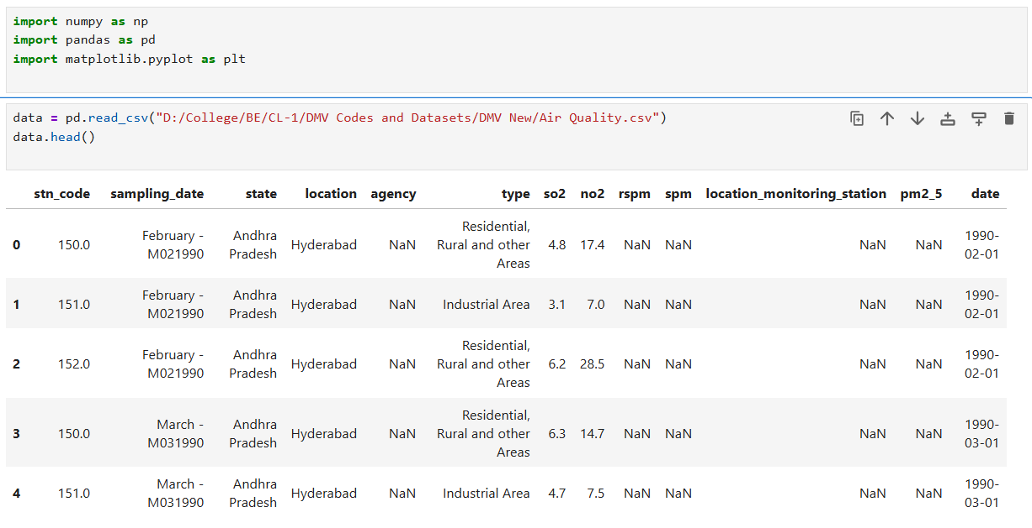
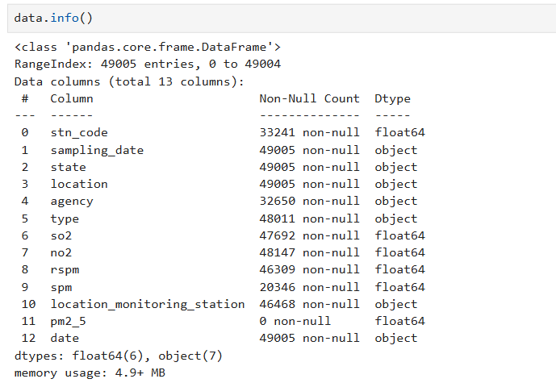
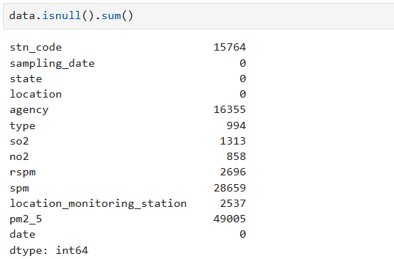
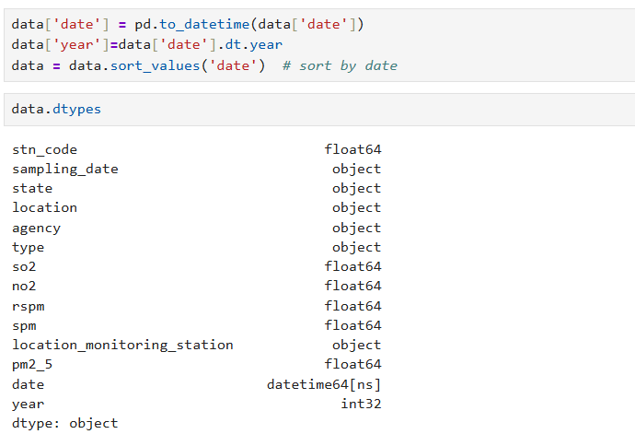
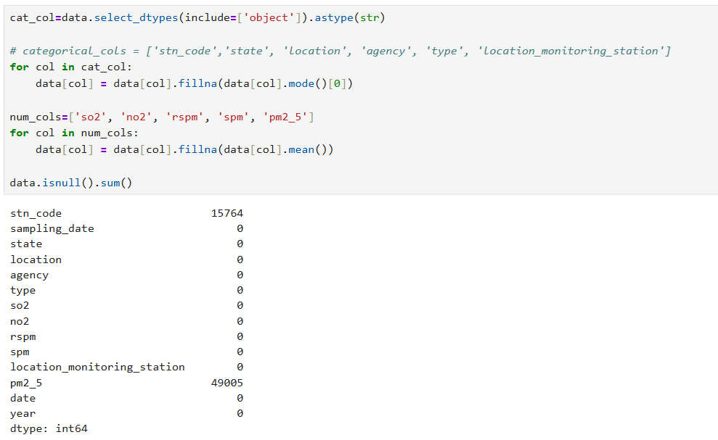
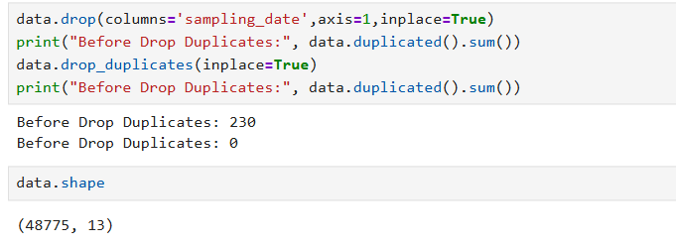

2. Create line plots or time series plots to visualize the overall AQI trend over time.
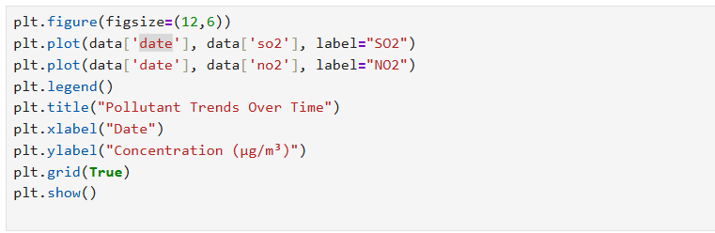
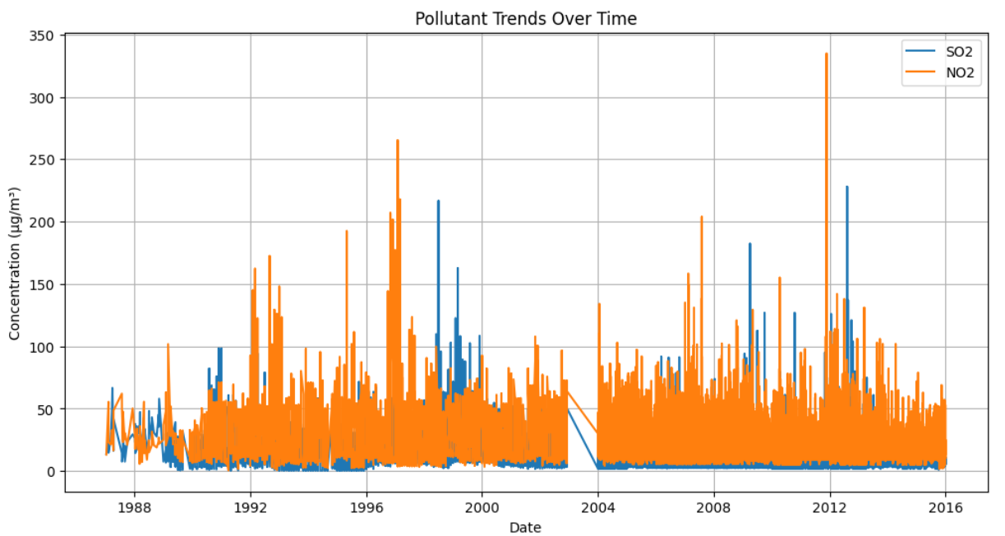

3. Plot individual pollutant levels (e.g., PM2.5, PM10, CO) on separate line plots to visualize their trends over time.
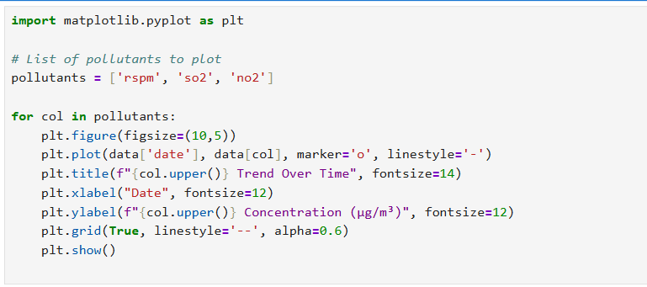
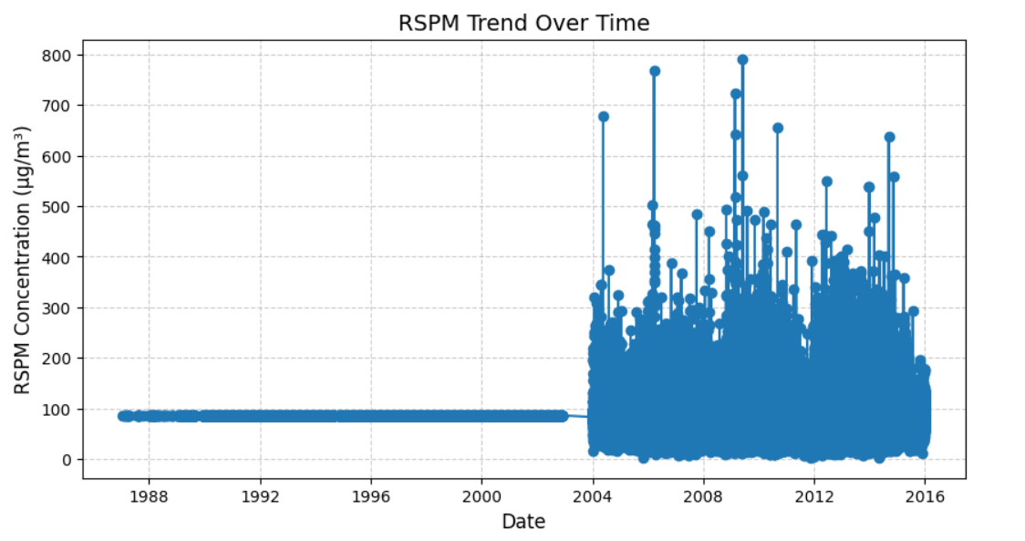
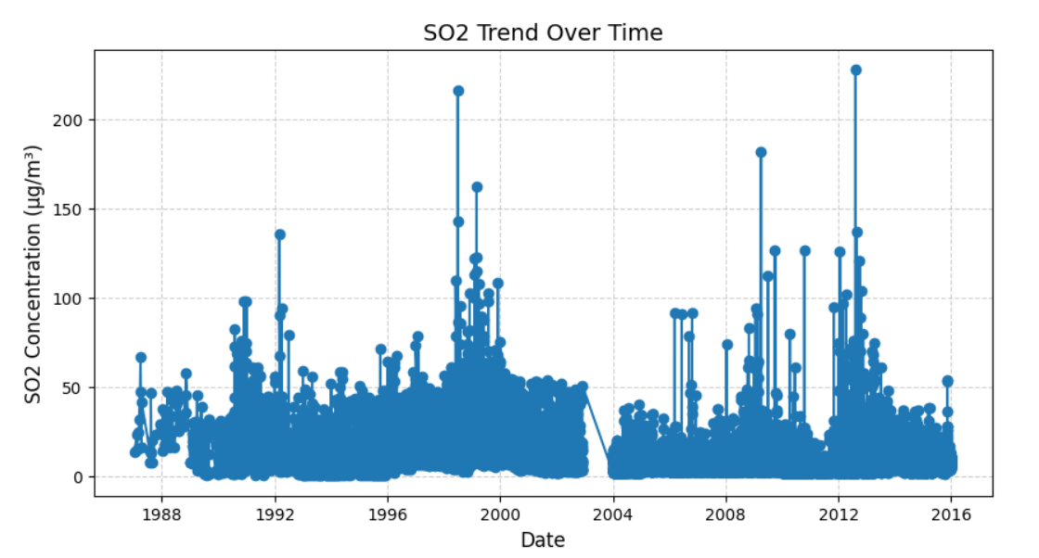
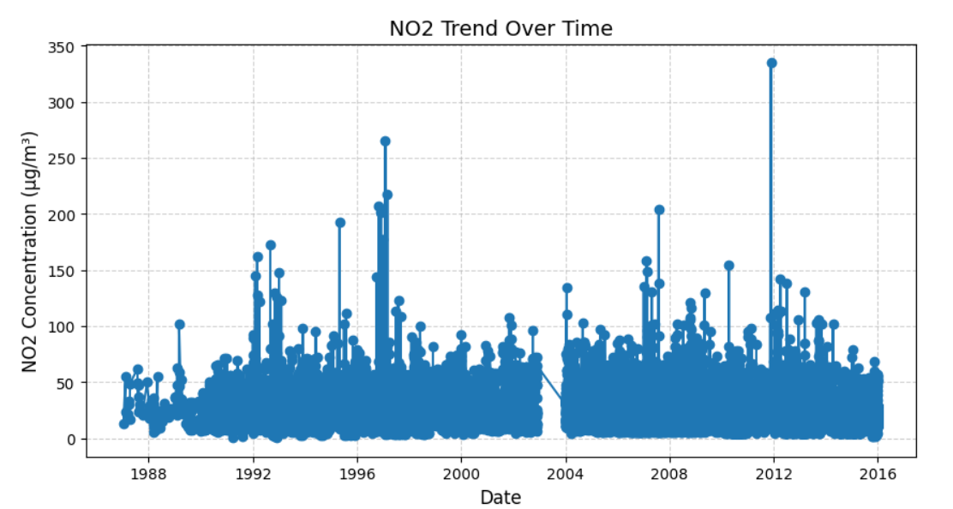

4. Use bar plots or stacked bar plots to compare the AQI values across different dates or time periods.
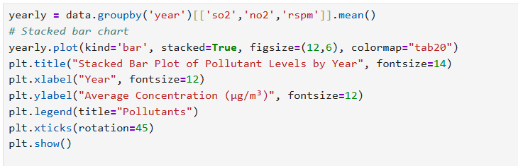
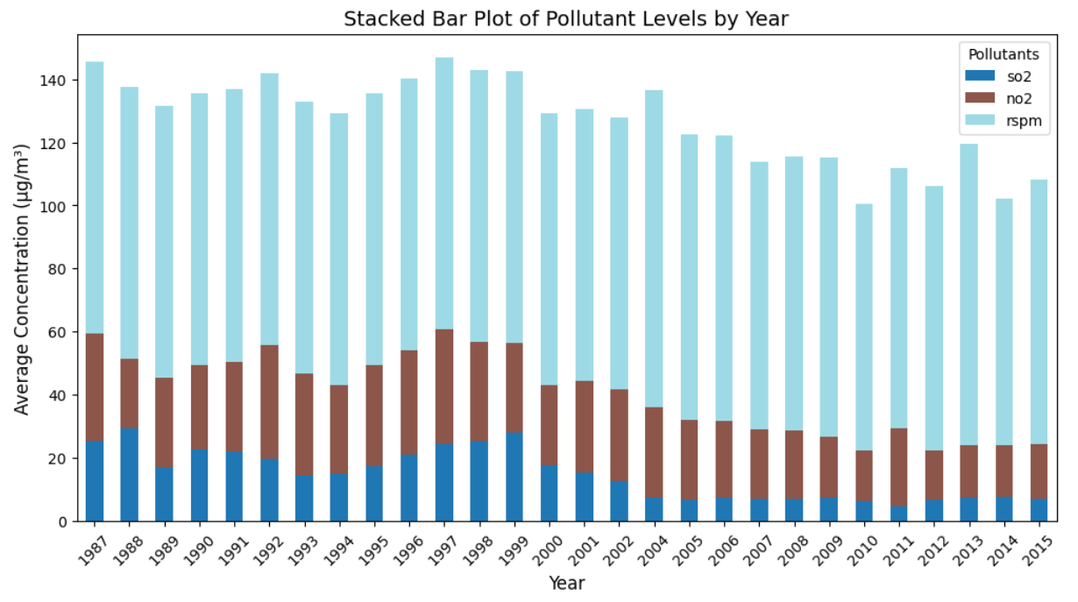

5. Create box plots or violin plots to analyze the distribution of AQI values for different pollutant categories.
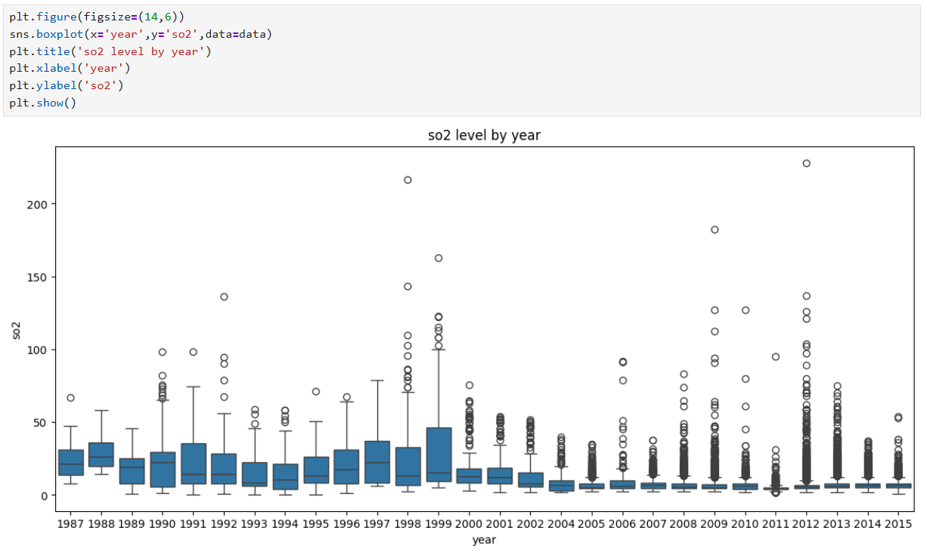
6. Use scatter plots or bubble charts to explore the relationship between AQI values and pollutant levels.
